Name_____________________________ Class Period_____
KHM Formative 3: Translations
Translate the basic design element below one inch to the left, two times. You should end up with three total trapezoids.

Translate each figure according to the translation rule.
(x,y) to (x, y – 4)
(x,y) to (x – 3, y – 3)
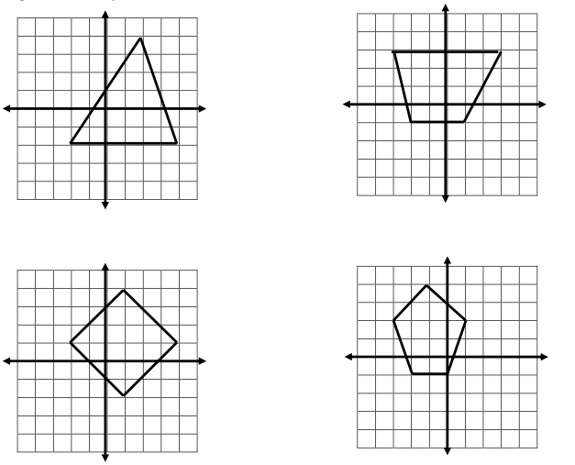
(x,y) to (x – 2, y)
(x,y) to (x + 1, y + 1)

Write the translation rule for the image of each figure.

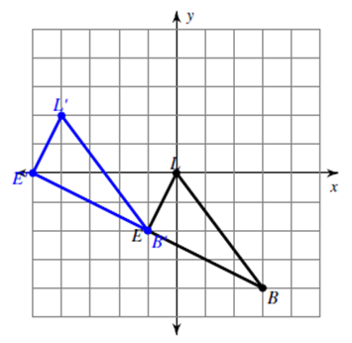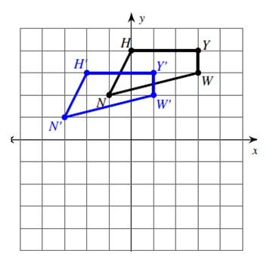

Complete the data table by writing the coordinates of the new point after applying the translation rule.
Original Point | Translation Rule | Image Point
I (3, 7) | (x + 7, y – 7) | I’ ( )
D (-1, -5) | (x – 4, y) | D’ ( )
K (0, 0) | (x, y + 10) | K’ ( )

