Name_____________________________ Class Period_____
KHM Practice: Rotations
Rotate the figure below clockwise 270 degrees around point P and draw the new image.

P

Rotate each figure around the point of origin according to the rule.
180 degrees
90 degrees counterclockwise
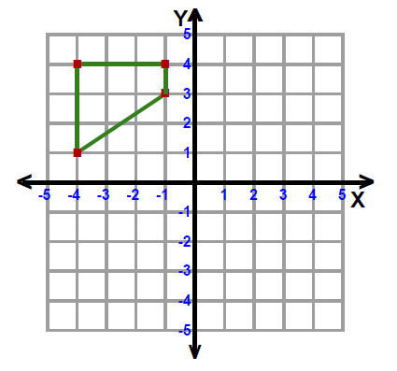
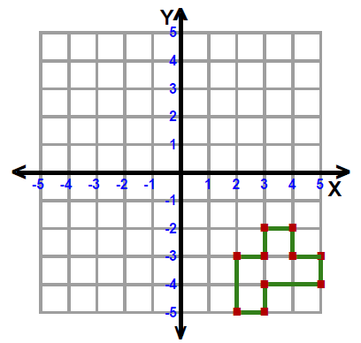
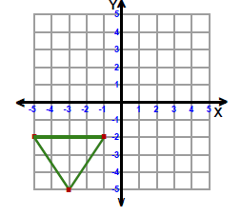
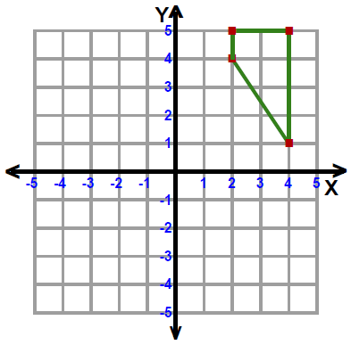
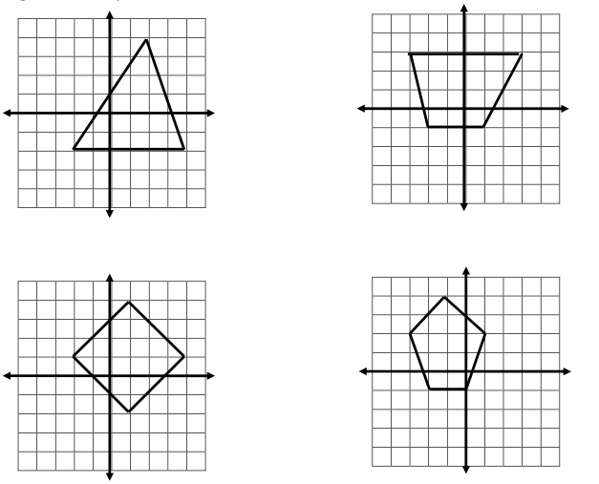
180 degrees
270 degrees clockwise

Record all the possible degrees and direction of each transformation.




