REFLECTION PRACTICE
Reflect the figures below according to each rule. Label your images.

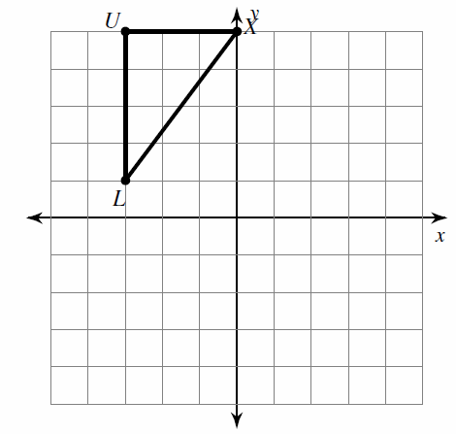
Reflect across the y axis Reflect across the x axis Reflect across x = 1

Use a ruler, angle, ruler, protractor, or other tools to reflect the figure below across the reflection line drawn.
BE AS PRECISE AS YOU CAN, SHOW YOUR WORK, AND LABEL YOUR IMAGE.
A

D

B

C

Reflect the figures below according to each rule. Label your images.

Reflect across the y axis Reflect across the x axis Reflect across x = 1
