For the equation y = 2x -+ 3, fill in the (x,y) table of values below. Then Use your ordered pairs to graph the equation. Be sure to label and title your graph. Then fill in the blanks to the right of the coordinate grid.

slope: ________
y-intercept: ________
rate of change: ________
starting value: ________
coefficient: _________

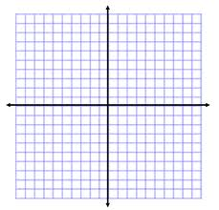
x | y

For the equation y = 2x -+ 3, fill in the (x,y) table of values below. Then Use your ordered pairs to graph the equation. Be sure to label and title your graph. Then fill in the blanks to the right of the coordinate grid.
x | y

slope: ________
y-intercept: ________
rate of change: ________
starting value: ________
coefficient: _________

